- Join the Quinnipiac River Watershed Association today:
- You can pay on line using Pay Pal feature/credit card online at our website: www.qrwa.org
- Or print a copy of this form and mail it along with your check payable to QRWA, at P.O. Box 2825, Meriden, CT 06450. All members receive a membership card

- Student/Senior Membership: $15 includes Membership Card
- Individual Membership $20 includes QRWA debossed silicone bracelet
- Family Membership $30 includes 2 QRWA debossed silicone bracelets and QRWA tote
- Bronze Member $75 includes 1 QRWA debossed silicone bracelet, QRWA tote
and QRWA t-shirt
- Silver Member $175 includes 1 QRWA debossed silicone bracelet, QRWA tote,
QRWA t-shirt, and QRWA picnic blanket in a bag
- Gold Member $350 includes 1 QRWA debossed silicone bracelet, QRWA tote,
QRWA t-shirt, QRWA picnic blanket in a bag, and QRWA Bag folding chair
- Platinum Member $700 (includes all above plus free canoe/kayak instruction for family of 4)
- Life Member $1000+ (includes all gifts plus use of our entire facility, including boats, for one day, UP TO 6 HOURS)

Name_______________________ Address________________________________________
City_________________________State_______________ Zip____________
Phone: ________________ Email address: ______________________________________
New or Renewal of membership (circle one)
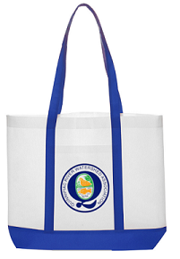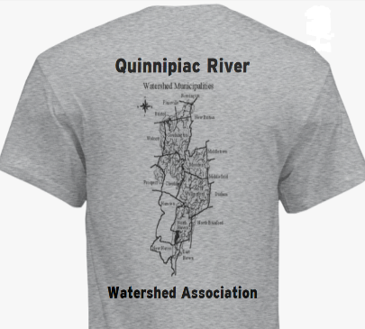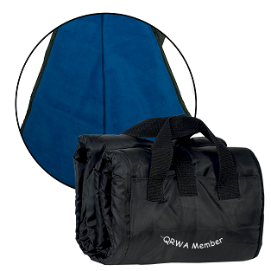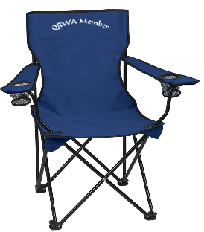
Membership items subject to change based on availability.

