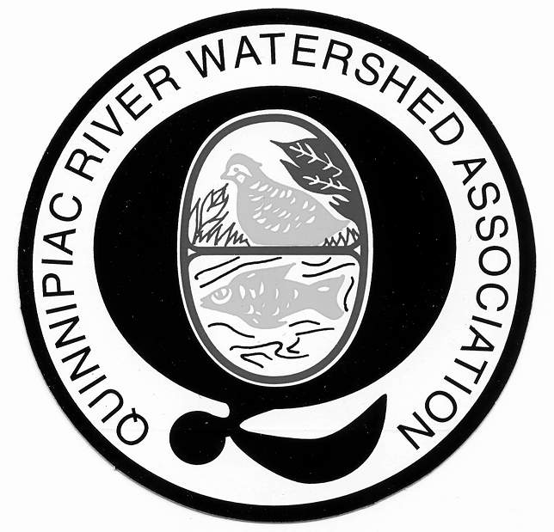

The Quinnipiac River Watershed Association
Annual Membership Meeting
September 9th, 2009
Augusta Curtis Cultural Center
175 East Main Street, Meriden, CT

- Call to Order

- Opening Remarks/President’s Report
  - Ginny Chirsky

- Financial Report
  - Mike Mordarski

- Executive Director Report
  - Mary Mushinsky

- Election of Directors
  - Nominating Chairman – Martin Mador

- Announcements
  - Next Board meeting – October 14th, 2009

- Adjournment of Annual Meeting Business

- Guest Speaker
  - Ian Christmann

PO Box 2825, Meriden, CT 06450 (203) 237-2237

